NY-18
2016 IE Strategy Memorandum

Updated on 5/17/16
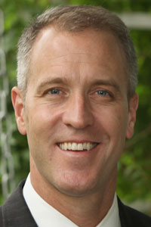
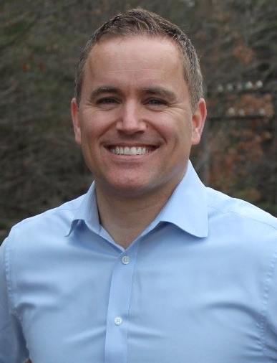

SEAN PATRICK MALONEY PHIL OLIVA
CoH: $1,607,922.90 CoH: $64,737.18
Date: 4/15/16 Date: 4/15/16 Occupation: Congressman Occupation: President of Gipper Communications
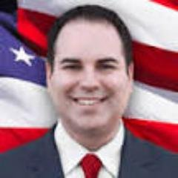

KENNETH DEL VECCHIO
CoH: $2,103
Date: 4/15/2016
Occupation: Filmmaker

SECTION I: Race Overview
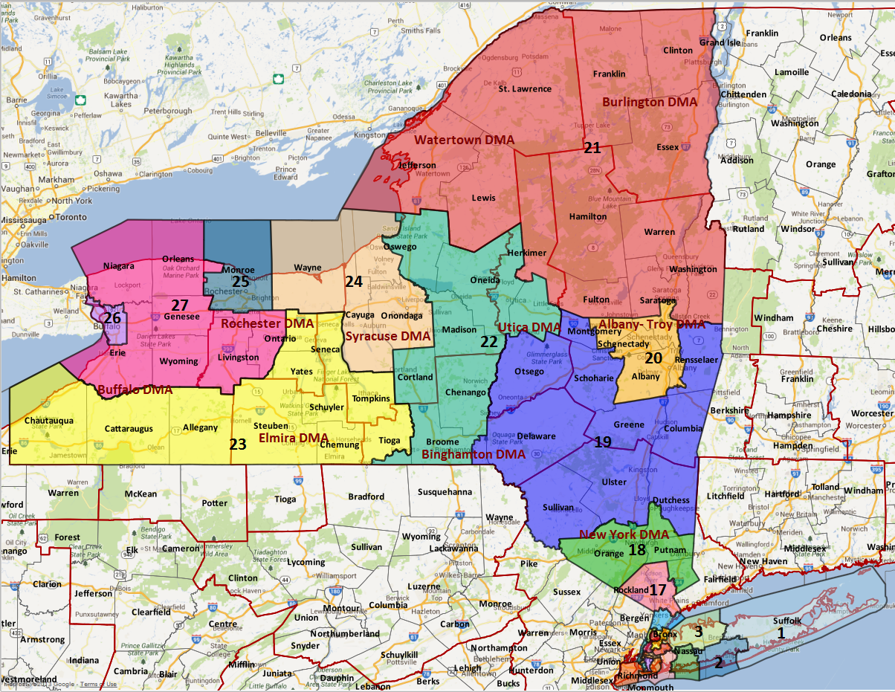

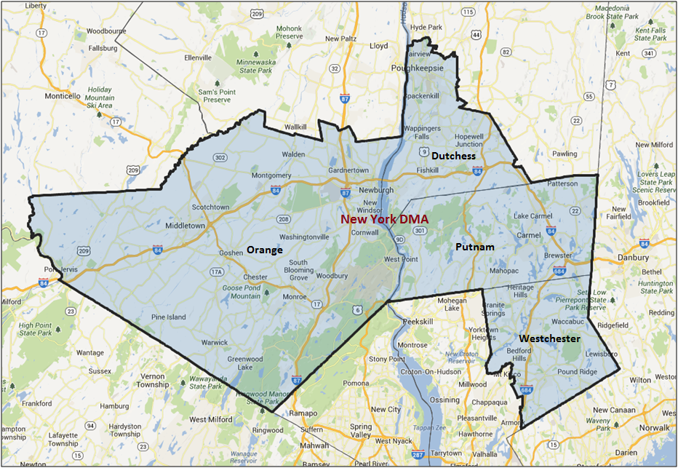

Media Market Costs

TV DMA | % of  CD | I.E.  35+ CPP | Cable CPP
NYC | 100% | $1975 | $650
NY-18 TOTALS: | 100.0%
Radio Landscape
DMA | Universe | CPP
NYC | 579,800 | $850
Poughkeepsie | 169,300 | $80

Digital Landscape
  - Persuasion universe size: 41,470
  - Audience extension (key demos): Independents & Democrats, 45+
  - Weekly budget for full coverage: $11,373.37
  - Reach
    - YouTube - 337,643
    - Pandora - 185,197

Presidential Statistics
Cycle | Candidate | Party | Vote
2012 | Obama | DEM | 52.2%
2012 | Romney | REP | 47.8%
2008 | Obama | DEM | 52.6%
2008 | McCain | REP | 47.4%

Congressional Statistics
Cycle | W/L | Candidate | Party | Vote
2014 | W | MALONEY | DEM | 50.95%
2014 | L | HAWORTH | REP | 49.05%
2012 | W | MALONEY | DEM | 51.9%
2012 | L | HAWORTH | REP | 48.1%

NCEC Data
Dem Performance: 50.7%
BVAP: 8.5%
Hispanic: 10.5%
Asian: 2.4%
Total Minority: 21.4%

Critical Dates
Filing Date: April 1st 2016
Primary Date: June 28th 2016

Summary of 2014 Cycle Spending by Outside Groups

TV Competitive Summary –New York City
Campaign/Group | Total GRPs | Total Dollars
DCCC | 800 | $748,889
Hayworth/NRCC | 167 | $84,182
House Majority PAC | 1,468 | $1,040,449
American Action Network | 99 | $188,225
American Unity PAC | 28 | $103,132
Patriot Prosperity PAC | 62 | $92,996
US Chamber of Commerce | 228 | $289,353
Good Guys vs Bad Guys | Total GRPs | Total Dollars
Good Guys | 2,268 | $1,789,338
Bad Guys | 584 | $757,888

Radio Competitive Summary – New York City
Campaign/Group | Total GRPs | Total Dollars
NRCC | 109 | $8,750

Good Guys vs Bad Guys | Total GRPs | Total Dollars
Good Guys | 0 | 0
Bad Guys | 109 | $8,750

Radio Competitive Summary – Poughkeepsie
Campaign/Group | Total GRPs | Total Dollars
NRCC | 198 | $13,875

Good Guys vs Bad Guys | Total GRPs | Total Dollars
Good Guys | 0 | 0
Bad Guys | 198 | $13,875

Pre-Election Day Voting

Type of  “Early Voting” | Start Date  End Date | Percent of  Vote Cast Using this Method | Brief Description  (where/how  do people vote) | Timeframe (when does the majority of voting happen)
Absentee Ballot/In person Absentee | Oct. 9th – Nov. 15th |  | If sent by mail, a returned ballot must be postmarked by the day before the election and received no later than the seventh day after the election. If submitted in person, the ballot must be received by close of polls on Election Day

SECTION II: DISTRICT OVERVIEW

- District Overview and Data

  - Political Landscape
- Democratic incumbent Sean Patrick Maloney is defending this seat for the second time, having defeated Nan Hayworth in 2012 with 51.9% of the two-way vote, and defeated her again in a 2014 rematch with 51.0% of the two-way vote.
- In an October 2015 DCCC IVR, Maloney’s favorability rating is +9 (35% fav, 26% unfav), and voters are split 50-50 on whether to re-elect him or elect someone else. Meanwhile, Republicans lead the generic congressional ballot by 7 points, 35% Democrat to 42% Republican.
- In a March 2015 campaign poll by Global Strategy Group, Republicans lead the generic congressional ballot by 4 points, 34% Democrat to 38% Republican. Maloney’s favorabilities were at +36, (58% fav, 22% unfav), and he led a generic Republican by 16 points, (49% Maloney, 33% Generic Republican).
- At the end of Q1, Maloney had $1.6 million cash on hand. Diana Hird may challenge Maloney in a Democratic Primary in June, although her ability to gather the necessary petition signatures remains to be seen.
- Phil Oliva, an aide to Westchester County Executive and 2014 gubernatorial candidate Rob Astorino, is also a former Pataki speechwriter. He announced on January 8th. Oliva lives in Somers, which is in Westchester County. We expect Somers to compose 3.7% of the district’s vote, with a DPI of 44.3%. Westchester is 11.9% of the expected vote, with a 2016 DPI of 51.0%.
- One Independent Party candidate has declared in this race, Scott Smith. He also ran in 2014, earning 2.3% of all ballots cast, or 4,294 votes. Maloney won in 2014 with 3,333 votes.

  - District Demographics
- New York’s 18th district is located just north of New York City. It contains all of Putnam and Orange counties, and parts of Westchester and Dutchess Counties. Divided in half by the Hudson River, the district stretches from Poughkeepsie in the north to Port Jervis in the west, the Connecticut border in the east, and Bedford in the south.

- This district’s population is concentrated around the cities of Poughkeepsie and Middletown, with additional density pockets around Newburgh and Heritage Hills. It is entirely in the New York media market, with a political cost per point of $1,733 and an issue cost per point of $2,079.

- The district is more diverse than many other competitive Northeast districts, with 17% of registrants being non-white. The largest racial group after White voters, at 83% of registrants, is Hispanic voters, at 8% of registrants and 10.5% of the voting age population. The voters in this district are 54% rural and 35% suburban, and by party registration are 35.4% Democratic, 31.4% Republican, 24.9% unaffiliated and 8.3% registered to third parties. The district’s voters are higher income than those in the state and in the country.

District Demographics

- Cook Partisan Voting Index: Even
- Urban Population: 10.5%
- Rural Population: 54.2%
- Suburb Population: 35.3%
- Median Income: $77,110
- Poverty Status: 6.1%
- Military Veterans: 9%
- Race/Ethnic Origin: 78.6% White; 8.5% Black; 2.4% Asian; 10.5 Hispanic

  - Electoral Context
- In 2012, Maloney defeated incumbent Republican Nan Hayworth in a newly redrawn district, 77% of which is in the old 19th, which Hayworth had represented, and 20% of which is in the former 22nd.
- March 2012 polling showed Republicans leading the generic ballot by 1 point, 42% to 41%. Hayworth led the initial head to head against Maloney by 6 points, 44% to 38%. In July 2012 polling, the generic ballot showed Republicans leading by 4 points, 43% to 39%, and Maloney trailed Hayworth by 11 points, 39% to 48%, with 13% undecided. October 2012 polling showed Maloney closing the gap, with Hayworth leading Maloney by 2 points in the initial head-to-head, 42% to 44%, Democrats leading the generic ballot by 2 points (43% to 41%), and Maloney leading Orange County 47% to 41%.
- Maloney won by 10,796 votes, earning 51.9% of the two-way. Maloney earned 52.4% in Orange, 55.0% in Dutchess, 52.0% in Westchester, and 45.5% in Putnam.
- The President slightly outperformed Maloney districtwide in 2012, earning 52.2% to Maloney’s 51.9%. Obama outperformed Maloney in Orange and Dutchess, earing 52.9% and 56.0% respectively, and underperformed Maloney elsewhere, earning 44.8% in Putnam, and 51.0% in Westchester.
- President Obama and Representative Maloney had significantly different winning coalitions, despite earning similar support districtwide. Obama earned more than double Maloney’s support among modeled Republicans, 24% to 10%, while Maloney won higher support among Democrats and Independents. Maloney earned 92% Democratic support and 55% Independent support, while Obama earned 82% Democratic support and 49% Independent support.
- In 2014, Maloney defeated Hayworth in a rematch, spending $4.2 million to Hayworth’s $3.5 million, and with Democratic IEs outspending Republicans $2.2 million to $1.2 million.
- In July 2014 benchmark polling, Republicans once again led by 1 point in the generic ballot, 38%-37%. Maloney had a +29 favorability rating (52% fav, 23% unfav), and Maloney led the initial head to head 49% to 39%. In Orange County, Maloney led the head to head, 47% to 34%.
- October 2014 polling done by GSG showed the generic ballot tied at 39%, and Maloney leading Hayworth 42% to 39%, with 3% going to the Independent Party candidate Scott Smith. When Smith was dropped from the race, Maloney led Hayworth 46% to 40%. Maloney led in Orange 45% to 39%.
- Maloney won by 3,333 votes, earning 51.0% of the two-way vote, or 49.7% of votes cast for all congressional candidates. He earned 52.6% of the two-way in Orange, 51.4% in Dutchess, 51.9% in Westchester, and 44.3% in Putnam. This was an improvement over his 2012 performance in Orange County, exceeding the 2014 Orange County DPI of 50.4%.
- The most recent DPI in this district is a 2016 DPI of 50.7%, a 1.1-point increase over the 2014 DPI of 49.6%.
- While the Presidential nominees will not spend a great deal of money here, a former US Senator from New York at the top of the ballot has the potential to influence Democrats further down the ticket. Secretary Clinton won 57.8% of this district’s vote in her last U.S. Senate election in 2006. In an October 2015 DCCC IVR in this district, Clinton’s favorability was -26% (30% fav, 56% unfav). Down-ticket impacts of the various potential Republican nominees are not yet clear. The 2016 US Senate race features Chuck Schumer, who is unopposed as of yet, and has won this district handily in the past. Governor Cuomo’s absence at the top of the ticket should prove a benefit compared to 2014.
- Five ballot measures may appear on the general election ballot. They include a new referendum process, changing the age requirement to vote in Presidential primaries, a family court judge provision, a bond for Alzheimer’s research, and a plan for Eastern Long Island townships to secede from Suffolk County, forming a new Peconic County. None of these are expected to drive turnout or swing support in this district, but we will continue to monitor their effect on the electorate.

  - Press Presence
- This district’s population is concentrated around the cities of Poughkeepsie and Middletown, with additional density pockets around Newburgh and Heritage Hills. It is entirely in the New York media market, with a current issue cost per point of $1,975.
- Outlets expected to cover this race include the Poughkeepsie Journal, Mid-Hudson News, Times Herald-Record, and occasionally the New York Times.

SECTION III: MESSAGE

Message Box

Democrat Self Frame  Sean was elected to represent the Hudson Valley in 2012, defeating Tea Party Congresswoman Nan Hayworth. Sean quickly built a reputation for working across the aisle to get results for the Hudson Valley, keeping businesses open and people in their homes, hiring more cops and firefighters, and securing millions in overdue compensation for veterans and their families. | Republican Self Frame  Washington is saddling us with trillions in debt, a stagnant economy and a foreign policy that has weakened America’s stature in the world. This new normal is generational theft – robbing our children of the opportunities we had growing up. Phil knows changing Washington won’t be easy, but as a dad he knows some things are worth fighting for.
Likeliest Attacks on Democrat  Maloney is a tax and spend liberal who follows Nancy Pelosi by cutting meidcare, veteran’s pensions and voting to give amnesty to illegal immigrants. | Best Attacks on Republican  Phil Oliva is a former political operative (“hack”) who is already making promises to the Tea Party that led to dysfunction and past government shutdowns. Oliva’s pledges to the Tea Party demonstrate that he can’t be trusted to move the Hudson Valley forward.

- Sean Patrick Maloney

- Short Biography
Born in Quebec, Canada, and raised in Hanover, New Hampshire, he earned his Bachelor of Arts and Juris Doctor from the University of Virginia. He entered politics as a volunteer for Bill Clinton's presidential campaigns, and later served as his senior West Wing adviser and White House Staff Secretary. After the Clinton Administration, he served as the First Deputy Secretary to New York Governors Eliot Spitzer and David Paterson.
Prior to being elected to Congress, he worked as an executive in a private equity firm and as an attorney. In 2006 he ran in the Democratic primary for New York Attorney General, but came in third to Mark J. Green and winner Andrew Cuomo. He was elected to the U.S. House of Representatives in 2012 after defeating Republican incumbent Nan Hayworth. He campaigned for the election as a moderate and is a member of the New Democrat Coalition. He is the first openly gay person to be elected to Congress from New York.

- Self-Frame
Sean was elected to represent the Hudson Valley in 2012, defeating Tea Party Congresswoman Nan Hayworth. Sean quickly built a reputation for working across the aisle to get results for the Hudson Valley, keeping businesses open and people in their homes, hiring more cops and firefighters, and securing millions in overdue compensation for veterans and their families.

- Likely Attacks
Cut medicare
Cut veteran’s pensions
Voted for Amnesty
Millionaire Congressman
Votes with Nancy Pelosi 73% of the time

- Assessment of Democratic Fundraising
DEMOCRAT | Q1 2015 | Q2 2015 | Q3 2015 | Q4 2015 | Q1 2016
Goal | $610,000 | $550,000 | $550,000 | $525,000 | $550,000
Actual Raised | $609,941 | $533,111 | $428,699 | $430,000 | $352,706

- Strengths and Weaknesses of Campaign
The candidate and his team are battle tested and can be trusted to run a good campaign. His chief of staff will again switch over to become his manager in the Spring. The only concern is the campaigns willingness to timely share information such as polling.

Maloney took some heat for his Iran vote, something that popped in their polling. They have been working on the legislative side to shore up national security.

- Phil Oliva

- Short Biography
Born and raised in the Bronx. Oliva earned a Bachelors from Siena College and an MBA from Rensselaer Polytechnic Institute. He was a speechwriter for Governor Pataki. Phil continues to serve as a top advisor to Westchester County Executive Rob Astorino. During Astorino’s 2014 gubernatorial bid, Phil co-authored, with Rob, an economic plan that was lauded as “A Plan for New York Revival” by the Wall Street Journal, saying it would “lift the state’s flagging economy” if enacted. He also co-authored an education plan that was praised as “serious, sound and comprehensive” by several nationally recognized education experts. Separately he is also the President of Gipper Communications, LLC, a New York-based business and communications consulting firm.
- Self-Frame
Washington is saddling us with trillions in debt, a stagnant economy and a foreign policy that has weakened America’s stature in the world. This new normal is generational theft – robbing our children of the opportunities we had growing up. Phil knows changing Washington won’t be easy, but as a dad he knows some things are worth fighting for.

NY-18 Research

Sean Patrick Maloney (Democratic Incumbent) Vulnerabilities

Sean Patrick Maloney was first elected to Congress in 2012. He had previously worked on Bill Clinton’s presidential campaigns and for his administration. Maloney also ran for New York Attorney General in 2006 but lost and then worked in Governor Spitzer’s administration. He currently serves on the Agriculture and Transportation committees. He has been active on rail safety and veterans’ issues.

Top Vulnerabilities
- Drones that were filming/taking photos of his 2014 wedding may have violated FAA rules—his office defended their use saying they did not violate any rules
- Voted with Republicans for a budget that included delays in enacting the ACA

Phil Oliva (Republican Challenger) Vulnerabilities

Phil Oliva is a former communications operative for New York Republican officials and was most recently a Senior Advisor to Westchester County Executive Rob Astorino. Oliva has worked in politics for New York Republicans for the last twenty years. After graduating from Siena College in 1995, Oliva worked as a Press Secretary for the New York State Assembly Republican Conference. He then worked as a Speechwriter for Governor George Pataki and went on to serve as District Director for Congressman John Sweeney. After returning to the Assembly for two years as a Communications Director, Oliva went into the private sector as a Communications Director for IMS Health, and eventually started his own communications firm in 2011. In 2012, he started working as a Senior Advisor to Westchester County Executive Rob Astorino where he served until announcing his run for Congress.

Oliva has promised to vote against raising the debt ceiling and to serve a maximum of four terms during his Congressional campaign. He also directed supporters at a Putnam County Firearm Owners Association meeting to visit his brother’s pro-gun blog. His brother, Tony Oliva, has posted a series of offensive comments on his blog calling Syrian refugees “rape-ugees,” criticized “New York values” as being anti-freedom, and wrote a post entitled “tear down all mosques, burn all Qurans.”

In January 2016, Oliva posted an online ad criticizing Rep. Maloney for putting together a petition to rename the Donald J. Trump State Park instead of focusing on issues like the debt, national security, and the economy.

SECTION V: Appendix

- 2016 Campaign Side Consulting Team
Media: SKDK
Mail: Mission Control
Polling: Global Strategies Group
Online/Digital: Anne Lewis
Self-research:

- Summary of Past Races and Important Differences for 2016
Recent Elections
- In 2012, Maloney defeated incumbent Republican Nan Hayworth in a newly redrawn district, 77% of which is in the old 19th, which Hayworth had represented, and 20% of which is in the former 22nd.
- March 2012 polling showed Republicans leading the generic ballot by 1 point, 42% to 41%. Hayworth led the initial head to head against Maloney by 6 points, 44% to 38%. In July 2012 polling, the generic ballot showed Republicans leading by 4 points, 43% to 39%, and Maloney trailed Hayworth by 11 points, 39% to 48%, with 13% undecided. October 2012 polling showed Maloney closing the gap, with Hayworth leading Maloney by 2 points in the initial head-to-head, 42% to 44%, Democrats leading the generic ballot by 2 points (43% to 41%), and Maloney leading Orange County 47% to 41%.
- Maloney won by 10,796 votes, earning 51.9% of the two-way. Maloney earned 52.4% in Orange, 55.0% in Dutchess, 52.0% in Westchester, and 45.5% in Putnam.
- The President slightly outperformed Maloney districtwide in 2012, earning 52.2% to Maloney’s 51.9%. Obama outperformed Maloney in Orange and Dutchess, earing 52.9% and 56.0% respectively, and underperformed Maloney elsewhere, earning 44.8% in Putnam, and 51.0% in Westchester.
- President Obama and Representative Maloney had significantly different winning coalitions, despite earning similar support districtwide. Obama earned more than double Maloney’s support among modeled Republicans, 24% to 10%, while Maloney won higher support among Democrats and Independents. Maloney earned 92% Democratic support and 55% Independent support, while Obama earned 82% Democratic support and 49% Independent support.
- In 2014, Maloney defeated Hayworth in a rematch, spending $4.2 million to Hayworth’s $3.5 million, and with Democratic IEs outspending Republicans $2.2 million to $1.2 million.
- In July 2014 benchmark polling, Republicans once again led by 1 point in the generic ballot, 38%-37%. Maloney had a +29 favorability rating (52% fav, 23% unfav), and Maloney led the initial head to head 49% to 39%. In Orange County, Maloney led the head to head, 47% to 34%.
- October 2014 polling done by GSG showed the generic ballot tied at 39%, and Maloney leading Hayworth 42% to 39%, with 3% going to the Independent Party candidate Scott Smith. When Smith was dropped from the race, Maloney led Hayworth 46% to 40%. Maloney led in Orange 45% to 39%.
- Maloney won by 3,333 votes, earning 51.0% of the two-way vote, or 49.7% of votes cast for all congressional candidates. He earned 52.6% of the two-way in Orange, 51.4% in Dutchess, 51.9% in Westchester, and 44.3% in Putnam. This was an improvement over his 2012 performance in Orange County, exceeding the 2014 Orange County DPI of 50.4%.
- The most recent DPI in this district is a 2016 DPI of 50.7%, a 1.1-point increase over the 2014 DPI of 49.6%.

Role of the I.E.
House Majority PAC’s early reservation was just for New York City cable on Weeks 2 and 1. They started communicating much earlier – right after Labor Day – and initially left a small gap in the middle, presumably for the IE to cover.

In September 2014, House Majority PAC cut back a chunk of their cable buy – leaving Congressman Sean Patrick Maloney uncovered on television during Weeks 5, 4, and 3. With the political environment deteriorating and DCCC IE polling showing a tight race, the IE decided to air one cable ad from the middle of Week 5 through Election Day. In Weeks 2 and 1, our advertising overlapped with House Majority PAC.

The role of the DCCC IE was to forcefully frame Nan Hayworth as a Tea Party radical. We used her own words (“I am proud to be a radical”) as the overall frame, and to lend credibility to attacks based on her extreme voting record and issue positions. Our ad hit her for an anti-choice vote, a vote against Planned Parenthood funding, and for supporting to privatize Social Security.

According to the 2014 exit memo, Congressman Maloney’s ability to maintain this seat in a tough cycle – even for New York Democrats – is largely a testament to the moderate brand he developed and to the cohesive and consistent application of the anti-Hayworth message from the campaign, DCCC, and HMP.

Although part of the New York media market, this district is moderate and tends to reflect the national environment. This race was decided by 3,000 votes – less than 2% of votes cast. The margin may have been more comfortable had Maloney won the Independence Party ballot line. This district should be easier for Congressman Maloney in a year with presidential turnout.

The DCCC IE made the right decision to protect a vulnerable incumbent and invest in this race to ensure the preferred anti-Hayworth message actually burned in.
The outcome of the 2014 race might have been different had the NRCC invested more significant resources here or had the narrative against Maloney been more cohesive and consistent across Republican spenders.

Summary: The 2014 DCCC IE Program aired one television spot in the New York City Media Market with a total of 800 GRPs over 5 weeks.

Ads run by DCCC in NY-18

- Spot 1 – D3C14-NY18-T01 “Radical” // New York City (800 GRPs): Used Hayworth tracking footage where she says she is “proud to be a radical.” Calls Hayworth a “Tea Party millionaire,” and hits her for opposing women’s right to choose, voting to defund Planned Parenthood, and wanting to privatize Social Security. Produced in studio.

- 2016 Targets
- In 2012, Board of Elections records show a turnout rate of 66.0% of all registrants (295,436 total ballots cast). Applying that turnout rate to the most recent available Board of Elections registrant count, we would expect 292,525 ballots to be cast in the district. Winning the district with 52% of the vote translates to a vote goal of 152,113. A one-point shift in support would equate to 2,925 votes.
- By registration, voters casting a ballot in 2012 were 36.3% Democrat, 28.4% unaffiliated or Independent, and 35.3% Republican.
- In 2012, 4.8% of voters who cast a ballot for President did not cast a ballot for Congress. Maloney lost more votes than his opponent in this way, as 3.9% fewer people cast votes for him than for President Obama, while 3.0% fewer people cast votes for Hayworth than for Mitt Romney. This translates to 5,765 fewer ballots cast for Maloney than for Obama, while 4,095 fewer ballots were cast for Hayworth than for Romney.

DEMOCRATS START THIS RACE FUNCTIONALLY TIED (50.6% SUPPORT), AND NEED ABOUT 4,200 VOTES TO ACHIEVE 52% SUPPORT. VICTORY DEPENDS ON THE FOLLOWING:
- EARN 86% SUPPORT AMONG REGISTERED DEMOCRATS, 56% SUPPORT AMONG REGISTERED INDEPENDENTS, AND 13% SUPPORT AMONG REGISTERED REPUBLICANS
- EARN 52.5% IN ORANGE COUNTY, AND MAINTAIN SUPPORT IN DUTCHESS (54.9%), PUTNAM (45%), AND WESTCHESTER (51.9%) COUNTIES
- MAINTAIN A MINIMUM 49% SUPPORT AMONG MEN
- RAISE AFRICAN AMERICAN AND HISPANIC TURNOUT BY 3 POINTS EACH TO 66.9% AND 60.9% RESPECTIVELY
- INCREASE YOUTH TURNOUT BY 3 POINTS TO 46.9%

